Steps to simple visualization and analysis of email corpora: INF 389J, 2007

First, use what your email client makes available. In Outlook, for example, there are two interesting views, by Sender:
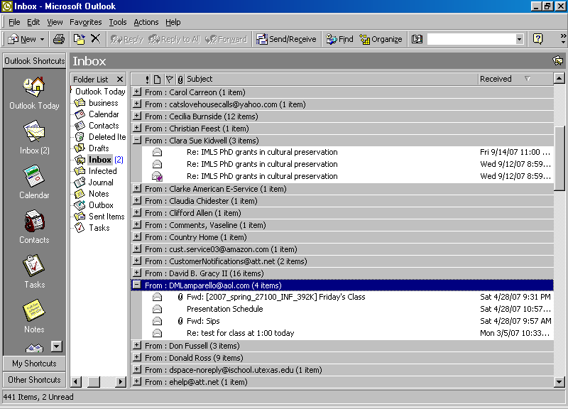

and by Message Timeline:
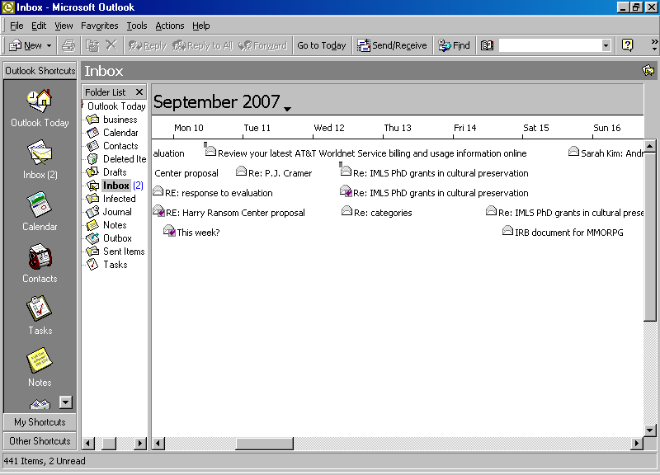

Visualizations like these can give a useful view of email data belonging to an individual, and they may be sufficient for learning enough about small collections to carry out an initial appraisal without reading every message, but it is clearly dependent upon having a client available that can actually access the email format—or upon conversion of the emails to a format that can be used with a client that makes visualizations like these possible. Unfortunately, useful as they are, it’s usually not very easy to export email data from such client views for any other sort of study.

For a more serious look at email data, it is therefore necessary to undertake preprocessing of the data of interest about the email. Most of the research that has been done about email has focused on making it more efficient, making an email client more attractive to customers, or especially recently, as we have seen in class, for analysis of email content, whether for forensic (organizational email corpora) or personal (individual email corpus) purposes. Most of this research has been carried out by computer scientists, which means that a lot of ad hoc programming has been done to carry it out, and when the projects were over the tools went with them. However, focusing on the header data from emails (to, from, dates, subject) can give a good idea of some of the principles I want to discuss here.

Harvesting headers

To lay hold of header data from a sample of email, you need to understand how email is structured and where to find it, which is a pretty arcane issue to begin with, since each email client program seems to do something different. This is why I asked you to get an account on the server, since then at least you should know where to find it. Usefully, too, you can capture information about the emails in your mailbox that can be used for visualization by simply using the utility “mail” and directing its output to a file: log in to your account and type:

mail > somefilename

The mail program will show the first 20 emails in your mailbox (assuming you have 20 emails, of course), and it will provide you with the header fields from, date, and subject. To add the next 20, type z and hit return; do so as long as you want to: depending on how much spam is included, you should gather around 100 items. Then to exit, type x and hit return. You should now have some basic data in the file you designated, which you can download to your own computer for further processing.

Massaging header data

You can begin by opening the file in a wordprocessor and getting rid of the leading line and a couple of other artifacts (you’ll see them easily because the data are in columns). Then load the file into into Excel or other spreadsheet, using in the Excel case Data/Get external Data/Import text file. In Excel you can of course sort in order to pinpoint correspondents and find out how many emails each was responsible for and when (remember that Outlook supplies this information but doesn’t let you have it). You will immediately see that to disambiguate correspondents with multiple emails, you will need to edit them to make them the same if you intend to use multiple entries. You can also edit the datestamp as I did to keep only the year, or in your case perhaps the day. These data may be disposed in multiple ways for visualization, which will call for reworking the original worksheet.

Visualizing data

There are not a lot of publicly-available tools for processing email data specifically, but there is a simple data visualization toolkit online that is an improvement on Excel’s charts. It’s called ManyEyes, and it is an experiment of one of IBM’s labs, designed to offer ordinary people access to tools for data visualization and the opportunity to upload datasets and work with them (Two similar sites are called Swivel and Data360). You can find it here:

http://services.alphaworks.ibm.com/manyeyes/home

On ManyEyes you can find two interesting visualization types for our purposes. I have experimented with the network diagram, derived from a table of three columns: year, correspondent, and number of emails. (Note that the network diagram used this way makes the temporal element an element of the network; unlike the work with a whole organization’s centrally managed email exemplified in the Enron work, a network diagram for a single person’s email will otherwise look something like a pompom and not be that informative because it offers no links between one’s correspondents.)

year person number
2003 Betty 1
2004 Carolyn 1
2003 Chrissy 4
2003 Deirdra 1
2003 Ed 1
2002 Elaine 2
2005 Elaine 2
2004 Hank 2
2002 Jim 2
2003 Jim 2
2004 Jim 3
2002 Jo 1
2004 Jo 1
2005 Julie 1
2002 Linda 2
2003 Linda 3
2004 Linda 4
2002 Nancy 2
2005 Samuel 1
2003 Sandra 1

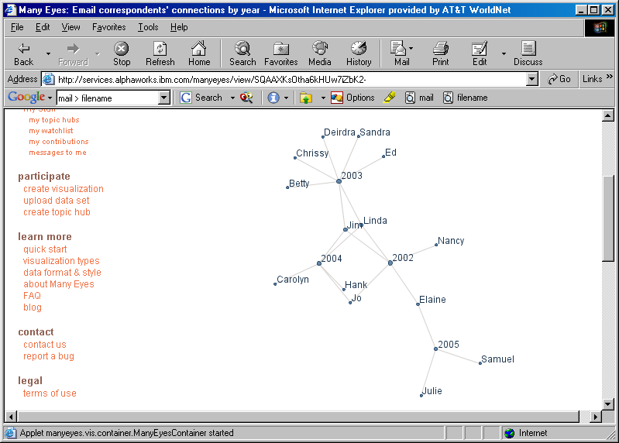

I also made a stack graph using a specially constructed table with a column for years and additional columns headed by correspondents’ names and containing the number of their emails by year.

year | Betty | Carolyn | Chrissy | Dierdra | Ed | Elaine | Hank | Jim | Jo | Julie | Linda | Nancy | Sam | Sandra
2002 | 0 | 0 | 0 | 0 | 0 | 2 | 0 | 2 | 1 | 0 | 2 | 2 | 0 | 0
2003 | 1 | 0 | 4 | 1 | 1 | 0 | 0 | 2 | 0 | 0 | 3 | 0 | 0 | 1
2004 | 0 | 1 | 0 | 0 | 0 | 0 | 2 | 2 | 1 | 0 | 4 | 0 | 0 | 0
2005 | 0 | 0 | 0 | 0 | 0 | 2 | 0 | 0 | 0 | 1 | 0 | 0 | 1 | 0

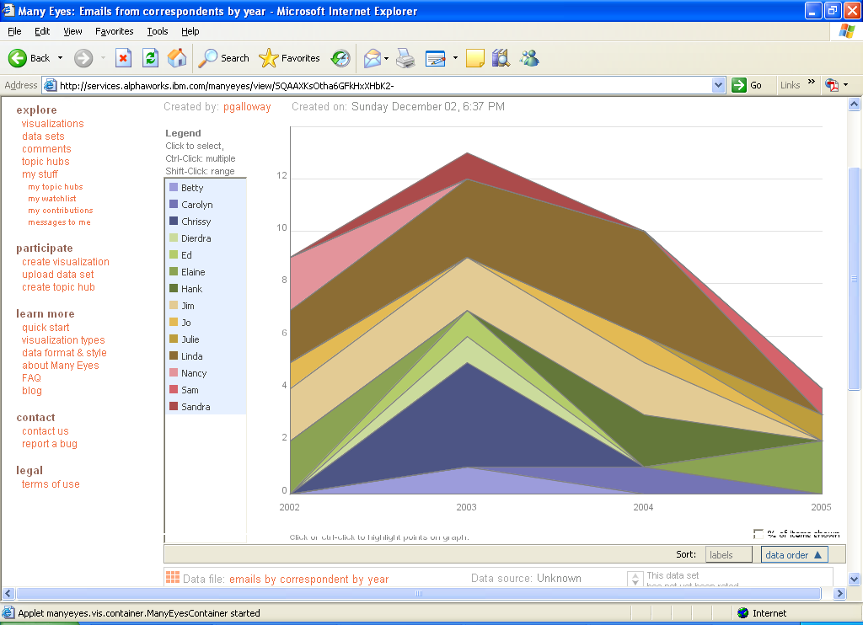

Both of these visualizations, drawn from a folder I kept of my email received at home from former colleagues in Mississippi, demonstrate in different ways how this particular set of email peaked in traffic and in number of correspondents in 2003, a year interestingly marked by the presence of correspondents not otherwise linked; 2002 and 2004, on the other hand, exhibited a sort of “secular trend” marked by correspondents who tended to have a more constant pattern of communication—in fact, people who were and remain my friends.

To use ManyEyes you will need to obtain a login, which you can do on the site. After that you can upload data and use the visualization tools you will find there. If you want to experiment, the datasets on the site are available for experimentation. And if you would rather not leave your data lying around on the site, you can erase it (there’s a garbage can icon) after you’ve experimented with it.

Next steps to appraisal use of automated tools

Once you have prepared a dataset and experimented with visualizing it, the next step is to apply a formalized appraisal scheme for choosing objects to remove.

But first it is necessary to consider just how “pure” the unappraised corpus is. You will already have noticed that in the case of email, we have already assented to an appraisal step that nobody really thinks much about: spam removal. This is in spite of the fact that few of us are at all well-informed about what kind of algorithms are used for spam removal, as well as the fact that we know full well that occasionally the spam filter gets it wrong and filters out something we very much want to see. So in dealing with email, the first thing to know is what kind of spam filter setup is being used. Secondly, each person uses at least slightly different personal patterns of “dynamic weeding” of email, based on personal or work importance or any of a number of concerns: in some ways this is why email does represent a very Jenkinsonian kind of corpus: people are very motivated to weed email and to allow it to be weeded (although it is worth considering the degree to which clever built-in tools like those in Outlook may make it possible for everyone to be as casual as skilled Unix users who can write scripts on the fly and who accordingly tend to keep everything and not use folders).

Hence, as mentioned before, sampling email, particularly received email, is something of a peculiar activity in the first place. Nevertheless, I would suggest that you attempt a simple exercise of taking a systematic sample from your experimental email corpus (depending on its size, say every third or fifth or tenth message header) and repeat the visualization exercise. I am satisfied that this exercise will show you why there is such great interest among social scientists and historians in the importance of creator-crafted, unweeded email collections, especially collections that span many years; in fact, there was such a discussion at the 2006 European conference on email curation held in Newcastle (see Ariadne, Issue 48: http://www.ariadne.ac.uk/issue48/curating-email-rpt/).

