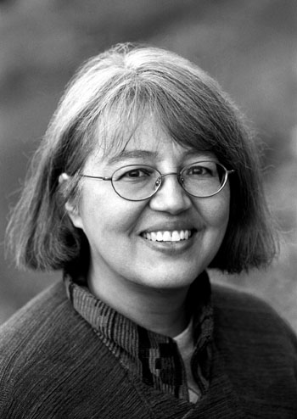 Loriene Roy
Celebrating Community, Collaboration, and Culture

Highlights: Diversity
Enrolled: White Earth Reservation, Minnesota Chippewa Tribe, Pembina Band.
Professor, School of Information, The University of Texas at Austin.
Professor, Center for Women’s and Gender Studies, The University of Texas at Austin
Director, “If I Can Read, I Can Do Anything,” A Reading Promotion Project for Schools
on Reservations. (http://www.ischool.utexas.edu/~ifican)
Research Associate, Four Directions, Pueblo of Laguna (New Mexico) Department of
Education, 1997-2001.
Principal Investigator, “Honoring Generations: Developing the Next Generation of Tribal Librarians,” Recruiting and Training Librarians for the 21st Century Grant ($341,294), U.S. Institute of Museum and Library Services, October 28, 2003.

Selected Publications Since 2000:
“Creating Opportunities and Opening Doors: Mentoring Students of Color,” in Wheeler, Maurice, ed., Unfinished Business: Race, Equity, and Diversity in Library and Information Science Education (Metuchen, NJ; London: Scarecrow, 2005), 131-146.
(with Mark Christal and Antony Cherian) “Stories Told: Tribal Communities and the Development of Virtual Museums,” Journal of Internet Cataloging: The International Quarterly of Digital Organization, Classification and Access 7 (1) (2005): 65-88.
“American Indian Literacy and Reading,” School Library Media Activities Monthly 20
(6) (February 2004): 23-25.
(with Becky Kyle) “Building a Native Bridge to WebJunction.org,” WebJunction.org, 18
May 2004.
(with Paul Resta and Mark Christal) “Digital Technology to Empower Indigenous Culture and Education,” In World Yearbook of Education 2004: Digital Technologies, Communities, and Education (London; New York: RoutledgeFalmer, 2004), 179–195.
(with Antony Cherian) “Indigenous Peoples and Information Technology,” In Osborne, Robin, ed., From Outreach to Equity: Innovative Models of Library Policy and Practice (Chicago: American Library Association, 2004), 58-60.
(with Daniel L. Alonzo) “Perspectives on Tribal Archives,” The Electronic Library 21 (5)
(2003): 422-427.
(with A. Arro Smith) “Supporting, Documenting, and Preserving Tribal Cultural
Lifeways: Library Services for Tribal Communities in the United States,” World Libraries 12 (1) (Spring 2002): 55-65.
(with David Raitt) “The Impact of IT on Indigenous Peoples,” The Electronic Library 21 (5) (2003): 411-413.
(with Peter Larsen) “Oksale: An Indigenous Approach to Creating a Virtual Library of Education Resources,” D-Lib Magazine 8 (3), <http://www.dlib.org/dlib/march02/roy/03roy.html>, (March 2002).
“`If I Can Read, I Can Do Anything,’: Promoting Reading on the Rez,” Texas Alcalde 89 (5) (May/June 2001): 16.
(with Clara Chu, Ann O’Neill, Carla Stoffle, and Elaine Yontz) “The Future for Latinos in Library Education: A Panel Presentation,” In Castillo-Speed, Lillian, ed. The Power of Language/El Poder de la Palabra: Selected Papers from the Second National REFORMA Conference, Englewood, CO, Libraries Unlimited, 2001, 35-41.
“The International Indigenous Librarians’ Forum: A Professional Life-Affirming Event,” World Libraries 10 (1/2) (Spring/Fall 2000): 19-30.
“To Support and Model Native American Library Services,” Texas Library Journal 76 (1) (Spring 2000): 32-35.

Selected Presentation Venues:
ALA Diversity Fair, IFLA, International Indigenous Librarians Forum, National
American Indian and Alaska Native Child Care Conference, National Conference on
Asian Pacific American Librarians, REFORMA National Conference, Tribal Archives,
Libraries and Museums National Conference, Transborder Library Forum, Tribal College
Librarians Professional Development Institute, World Indigenous Peoples Conference on
Education

Selected Service:
American Indian Library Association President, 1997-1998.
American Library Association
Carla Hayden’s Presidential Advisory Committee
Carol Brey-Casiano’s Presidential Advisory Committee, Diversity Subcommittee
Council Committee on the Status of Women in Librarianship, 1997-1999.
International Relations Committee, East Asia and the Pacific Subcommittee, Chair, 2001-2004.
2006 Joint Conference of Librarians of Color
Steering Committee; Evaluation Committee,
Presidential Task Force on Equity of Access: Towards Full Digital Inclusion,
Member, 2000-2002.
Spectrum Initiative Jury, Member, 2001-2002.
Spectrum Initiative Leadership Institute Committee, Member, 2000, 2001.
Spectrum Initiative Steering Committee, Member, 1997-2000.

