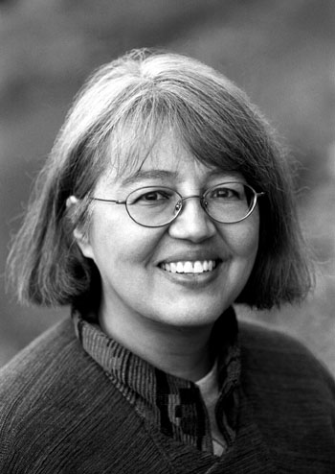
Loriene Roy
Celebrating Community, Collaboration, and Culture

Highlights: Gender Issues

Professor, School of Information, The University of Texas at Austin, Austin.
Professor, Center for Women’s and Gender Studies, The University of Texas at Austin.

Selected Publications:

“Creating Opportunities and Opening Doors: Mentoring Students of Color,” in Wheeler,
Maurice, ed., Unfinished Business: Race, Equity, and Diversity in Library and Information Science Education (Metuchen, NJ; London: Scarecrow, 2005), 131-146.
“Diversity in the Classroom: Incorporating Service-Learning Experiences in the Library and Information Science Curriculum,” Journal of Library Administration 33 3/4 (2001): 213-228.
“The Minority Liaison Officer in the Graduate School of Library and Information Science, The University of Texas at Austin,” Texas Library Journal 71 (3) (Fall 1995): 136-138.
“American Indian Women in Higher Education,” In Proceedings of the 8th Annual
International Conference for Women in Higher Education, El Paso, UTEP, 1995, 476-484.

Honors:

Certificate of Appreciation for Making a Significant Contribution to Advancing the Awareness of Women’s History, Austin Public Library, March 22, 2002.
Guest Coach, University of Texas at Austin, Women Longhorns Basketball, January
2002, 2000.

Selected Presentation Venues:

ALA, ALISE, American Theological Library Association, Art Libraries Society of North America, Barents Libraries Conference, Goteberg International Book Fair, IFLA, International Conference for Women in Higher Education, International Indigenous Librarians Forum, Library & Information Association of New Zealand Aotearoa, PLA, Sequoyah Research Center Symposium, Transborder Library Forum, Tribal Archives, Libraries and Museums National Conference, World Indigenous Peoples Conference On Education.

Selected Service:

American Indian Library Association, President, 1997-1998.
ALA, Council Committee on the Status of Women in Librarianship, Member, 1997-1999.
University of Texas at Austin, Center for Women’s and Gender Studies.
Executive Committee, 2002-03, 2003-04.
Steering Committee, 2004-.
Governance Committee, 2004-.
Search Committee for the Associate Director, 2005.
Subcommittee Planning a Women’s Studies Master’s of Arts Degree, 2000.

