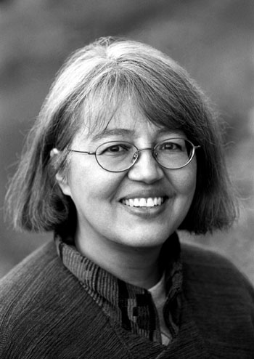
Loriene Roy
Celebrating Community, Collaboration, and Culture

Highlights: International Librarianship

Selected Publications:

(with Deborah Smith) “A Gathering of Readers: Schools Serving Indigenous Children Collaborate on a Virtual Celebration of Reading and Culture,” 2005 School Library Association of New Zealand Aotearoa (SLANZA) Conference Proceedings, Auckland, Aotearoa/New Zealand, July 2005. [CD ROM]
(with Sandra Littletree and Robert L. Yazzie, Jr.) “The Keepers of Knowledge: Fourth
International Indigenous Librarians’ Forum,” American Indian Libraries Newsletter 28 (1) (Fall 2005): 1-2.
“Winds of Change, Libraries in the 21st Century: The 2002 Annual Conference of
LIANZA (Library & Information Association of New Zealand Aotearoa),” American Indian Libraries Newsletter 25 (2) (Winter 2002): 1-2.
“Second International Indigenous Librarians’ Forum,” International Leads 15 (4)
(December 2001): 6.
“The International Indigenous Librarians’ Forum: A Professional Life-Affirming Event,” World Libraries 10 (1/2) (Spring/Fall 2000): 19-30.

Selected Fellowships, Grants, Special Honors:

The Embassy of the United States of America, Wellington, New Zealand, Public Affairs Section. Mutual Educational and Cultural Exchange Act Grant, July 2002.

Selected International Presentation Venues:

- ALA/Canadian Library Association Annual Conference (Toronto: 2003)
- Barents Libraries Conference (Jokkmokk, Sweden: 2001)
- Goteborg (Sweden) International Book Fair (2001)
- IFLA (Berlin: 2003; Buenos Aires: 2004)
- International Indigenous Librarians Forum (Auckland, 1999; Jokkmokk, Sweden: 2001; Santa Fe, New Mexico: 2003; Regina, Saskatchewan, Canada: 2005)
- Library and Information Association of New Zealand Aotearoa (Wellington: 2002)
- School Library Association of New Zealand Aotearoa (SLANZA) (Auckland, Aotearoa-New Zealand 2005)
- Transborder Library Forum (Albuquerque, New Mexico: 2000; College Station, Texas: 2003)
- World Indigenous Peoples Conference on Education (Hilo, HI: 1999; Stoney Reserve, Canada: 2002; Hamilton, Aotearoa-New Zealand, 2005)
- Guest lectures: University of Auckland (Aotearoa-New Zealand); Victoria University (Wellington, Aotearoa-New Zealand), Wananga O Raukawa (Otaki, Aotearoa-New Zealand; South Wales School of Information, Technology and Management, (Sydney, Australia)

Selected Membership:

Te Ropu Whakahau (Maori in Libraries and International Relations Committee, East Asia and the Pacific Subcommittee, Member, 2000-2004.

Selected Service:

International Relations Committee, East Asia and the Pacific Subcommittee, Chair, 2001-2004.
Bill & Melinda Gates Foundation Access to Learning Award 2003,
2004, Selection Committee, Member.

