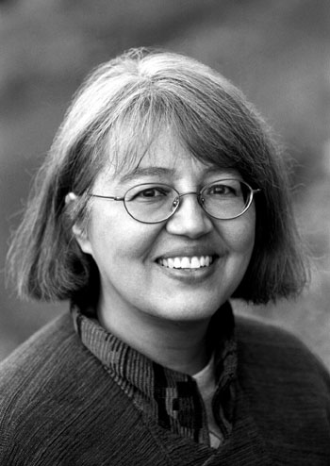 Loriene Roy
Celebrating Community, Collaboration, and Culture

Highlights: Leadership, Fundraising, Marketing, Staff Development
Professor, School of Information. Classes include “Public Libraries.”
Director: “If I Can Read, I Can Do Anything”: A National Reading Club for Native
Children.
Principal Investigator: “Honoring Generations: Developing the Next Generation of Tribal Librarians,” Recruiting and Training Librarians for the 21st Century Grant ($341,294).

Selected Publications
(with Beth Hallmark and Amanda Traviss) “WebJunction.org: Where Minds Meet to Support Public Access Computing,” The Electronic Library 22 (4): 314-316.
(with Daniel Alonzo) “What’s Marketing Got to Do With It?” ERIC, ED 482 248, 2003,
9 p.
(with Antony Cherian, eds.) “Getting Libraries the Credit They Deserve”: A Festschrift in
Honor of Marvin H. Scilken. Metuchen, NJ; London: Scarecrow, 2002.
“Marketing in Public Libraries,” The Acquisitions Librarian 28 (2002): 215-235.

Selected Presentation Venues:
ALA, ALISE, American Theological Library Association, Art Libraries Society of North America, Barents Libraries Conference, Goteberg International Book Fair, IFLA, International Indigenous Librarians Forum, Library & Information Association of New Zealand Aotearoa, PLA, Sequoyah Research Center Symposium, Transborder Library Forum, Tribal Archives, Libraries and Museums National Conference, World Indigenous Peoples Conference On Education,

Selected Honors:
2005 Mover and Shaker, Library Journal.
2005 Texas Exes Teaching Award, The University of Texas at Austin.
Outstanding Alumna 2002, School of Information Resources and Library Science, University of Arizona.
Tocker Foundation Outreach Grant ($100,000), 2002-2003.
Joe and Bettie Branson Ward Excellence Award for Research, Teaching, or Demonstration Activities that Contribute to Changes of Positive Value to Society, The University of Texas at Austin, 2001.
Tocker Foundation Outreach Grant ($29,000), 2000.
James W. Vick Texas Excellence Award for Academic Advisors, GSLIS, The University of Texas at Austin, 1992.
University Research Institute Faculty Travel Grant, The University of Texas at Austin,
1992.
Texas Excellence Teaching Award for Advisors, GSLIS, The University of Texas at
Austin, 1991.
Texas Excellence in Teaching Award, GSLIS, The University of Texas at Austin, 1988.

Advisory Boards:
El dia de los ninos/El dia de los libros, Advisory Committee, 2004-2005, 2005-2006.
Heart of the Community: The Libraries We Love, Berkshire Publishing Group, 2005-.
International Children’s Digital Library. Advisory Board, 2002-.
WebJunction.org. OCLC. Bill & Melinda Gates Foundation. Public Access Computing Portal, Advisory Committee, 2002-.
Sequoyah Research Center. Advisory Board, 2001-.
Texas State Library and Archives Commission TexShare Advisory Board, 2005-.

Selected Service:
American Indian Library Association, President 1997-1998.

ALA:
Carla Hayden’s Presidential Advisory Committee.
Carol Brey-Casiano’s Presidential Advisory Committee, Diversity Subcommittee.
Council Committee on Committees.
Council Committee on Education, Chair.
Council Committee on the Status of Women in Librarianship
Councilor at Large, 1997-2000, 2004-2006.
Education Assembly, Chair.
International Relations Committee, East Asia and the Pacific Subcommittee, Chair
Joint Conference of Librarians of Color, Steering Committee, Evaluation Committee.
Nominating Committee, Member.
Presidential Task Force on Equity of Access: Towards Full Digital Inclusion.
Sarah Long’s Literacy Initiative, Chair, 1998-2000.
Spectrum Initiative Jury, Leadership Institute Committee, Steering Committee.
VerizonWebsite Advisory Committee, 2000-2001.

Bill & Melinda Gates Foundation Access to Learning Award Selection Committee.

