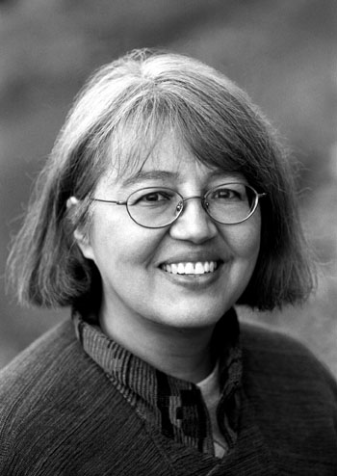
Loriene Roy
Celebrating Community, Collaboration, and Culture

Highlights: Library History

Professor, School of Information, The University of Texas at Austin. Courses taught
include “Public Libraries,” “Information Resources in the Humanities,” and “Information Resources in the Social Sciences”

Selected Publications:

“From Tribal Records Repository to Corridor on Powwow Super Highway: Library Development for American Indians Since the Late 1960s,” Svensk Biblioteksforskning (Swedish Library Research) 14 (3) (2002): 127-134.
“Black Hawk” (34-35); “Black Hawk War” (36-38); “Black Hills” (38-39); “Ojibwa” (260-261); “Potawatomi” (286); and “Sacajawea” (302-303). In Rodriguez, Junius P., ed., The Louisiana Purchase: An Encyclopedia. Santa Barbara, CA: ABC-Clio. 2002.
(with A. Arro Smith) “Supporting, Documenting, and Preserving Tribal Cultural
Lifeways: Library Services for Tribal Communities in the United States,” World Libraries 12 (1) (Spring 2002): 55-65.
(with Antony Cherian, Mark Christal, Marty Kreipe de Montano, and Paul Resta) “Virtual Museum Collaborations for Cultural Revitalization: The Four Directions Model,” Museums and the Web 2001 Proceedings, Seattle, WA, March 2001. [CD ROM]
“Personality, Tradition, and Library Spirit: A Brief History of Librarian Education,” In Roy, Loriene and Sheldon, Brooke, eds. Library and Information Studies Education in the United States, London, Mansell, 1998, 1-15.
“Michael Dorris” (vol. 4, 455); “Basil Johnston” (vol. 6, 752-753); “Nanabosho” (vol. 7, 937); “Ojibwe” (contributor, vol.7, 1003-1008); “Quillworking and Quillworkers” (vol 8, 1110-1113); and “Windigo” (vol. 10, 1397-1398) In Birchfield, D. L., ed., Encyclopedia of North American Indians, New York, Marshall Cavendish, 1997.
“Library Spirit: The Library School Experience and Early Professional Work During Progressive Era Texas and Illinois,” ERIC, ED 393 467, 1996, 40 p.
“A View of Main Street: The Use of Postcards in Historic Preservation,” Popular Culture
in Libraries 3 (2) (Spring 1996): 141-158.
“Ojibwa,” In Galens, Judy, Anna Sheets, and Robyn V. Young, eds. Gale Encyclopedia
of Multicultural America, Detroit, MI, Gale, 1995, 1016-1029.
“Incorporating Oral History into the Curriculum,” ERIC, ED 399 957, 1994, [13 p.].
“Planning an Oral History Project,” Journal of Youth Services in Libraries 6 (4) (Summer 1993): 409-413.
Recovering Native Identity: Readers' Advisory Services for Non-Reservation Native
Americans,” Collection Building 12 (3/4) (Summer 1993): 73-77.
“Displays and Displacement of Circulation,” Collection Management 17 (4) (Spring
1993): 57-77.
(with Don Drummond) “‘It Wasn't a Job. It Was a Way of Life,’ Jerre Hetherington and the Texas Library Association,” Texas Library Journal 9 (1) (Spring 1993): 25-27.
(with Don Drummond) “Jerre Hetherington and the Texas Library Association, Part II,”
Texas Library Journal 69 (2) (Summer 1993): 66-68.
“The Oral History Project of TLA,” Texas Library Journal 68 (2) Summer 1992: 59-62.

Book reviews in American Indian Libraries Newsletter, Multicultural Review, and School Library Journal

Selected Presentation Venues:

Art Libraries Society of North America, Goteborg International Book Festival, IFLA, Library History Seminar, “Storytelling in the Millennium: Finding Meaning Through Narrative After Postmodernism” Conference, “U. S. Latinos and Latinas & World War II: Changes Seen, Changes Wrought” Conference.

