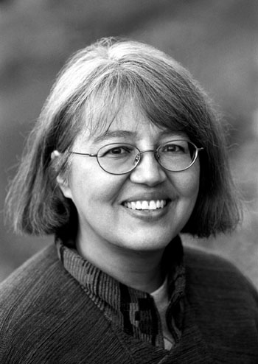
Loriene Roy
Celebrating Community, Collaboration, and Culture

Highlights: Library Instruction and Reference

Professor, School of Information, The University of Texas at Austin.
Classes taught include: “Library Instruction and Information Literacy,” “Information Resources in the Humanities,” and
“Information Resources in the Social Sciences.”

Selected Presentation Venues:

ALA, American Theological Library Association, Goteberg International Book Fair, IFLA, International Indigenous Librarians Forum, Library & Information Association of New Zealand Aotearoa, PLA, Sequoyah Research Center Symposium, Transborder Library Forum, World Indigenous Peoples Conference On Education.

Current Advisory Boards:

El dia de los ninos/El dia de los libros, Advisory Committee, 2004-2005, 2005-2006.
Heart of the Community: The Libraries We Love, Berkshire Publishing Group, 2005-.
International Children’s Digital Library. Advisory Board, 2002-.
WebJunction.org. OCLC. Bill & Melinda Gates Foundation. Public Access Computing Portal, Advisory Committee, 2002-.
Sequoyah Research Center. Advisory Board, 2001-.
Texas State Library and Archives, TexShare Advisory Board, 2005-.
Consulting: tribal college, community/public, and school libraries.

Selected Publications:

(with Beth Hallmark and Amanda Traviss) “WebJunction.org: Where Minds Meet to Support Public Access Computing,” The Electronic Library 22 (4): 314-316.
(with Becky Kyle) “Building a Native Bridge to WebJunction.org,” WebJunction.org, 18
Mary 2004.
with Aimee Akerman) “OKSALE: Building a Culturally Responsive Virtual Library of
Education Resources for a Tribal College,” Education Libraries 25 (2) (Winter 2002): 26-28.
with Peter Larsen) “Oksale: An Indigenous Approach to Creating a Virtual Library of
Education Resources,” D-Lib Magazine 8 (3),
<http://www.dlib.org/dlib/march02/roy/03roy.html
(with Eric Novotny) “How Do We Learn? Contributions of Learning Theory to
Reference Service and Library Instruction,” The Reference Librarian 69/70 (2000): 129-139.>, (March 2002).
“Diversity in the Classroom: Incorporating Service-Learning Experiences in the Library and Information Science Curriculum,” Journal of Library Administration 33 3/4 (2001): 213-228.
(with Raymond J. Mooney) “Recommending Using Learning for Text Categorization,” In Proceedings of the SIGIR-99 Workshop on Recommender Systems: Algorithms and Evaluation, Berkeley, CA, August, 1999.
(with Raymond J. Mooney and Paul N. Bennett) “Book Recommending Using Text Categorization with Extracted Information,” In Papers from the AAAI-98/ICML-98 Workshop on Learning for Text Categorization, Madison, Wisconsin, 1998, 49-54.
“Reference Accuracy,” In Whitlatch, Jo Bell, ed. Library Users and Reference Services, Binghamton, NY, Haworth Press, 1995.
“Recovering Native Identity: Readers' Advisory Services for Non-Reservation Native
Americans,” Collection Building 12 (3/4) (Summer 1993): 73-77.

Selected Service:

Reference and User Services Association
Publications Committee, 2004-.
Management and Operation of Public Services Section (MOPSS), Research and
Statistics Committee, Chair, 1996-1997.
Management and Operation of User Services Section (MOUSS), Executive
Committee, 2002-2004.
Management and Operation of User Services Section (MOUSS), Secretary, 2002-
2004.

