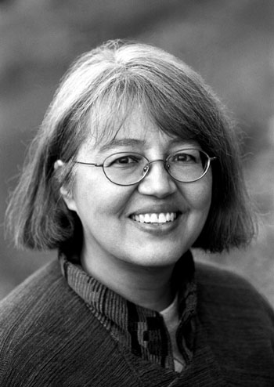
Loriene Roy
Celebrating Community, Collaboration, and Culture

Highlights: IT Issues
Professor, School of Information, The University of Texas at Austin.
Professor, Center for Women’s and Gender Studies, The University of Texas at Austin.
Director, “If I Can Read, I Can Do Anything,” A Reading Promotion Project for Schools on
Reservations.
Principal Investigator: “Honoring Generations: Developing the Next Generation of Tribal
Librarians,” Recruiting and Training Librarians for the 21st Century Grant ($341,294), U.S. Institute of Museum and Library Services.
Research Associate, Four Directions, Pueblo of Laguna (New Mexico), Department of
Education, 1997-2001.

Selected Presentation Venues:
ALA, American Theological Library Association, Goteberg International Book Fair, IFLA, International Indigenous Librarians Forum, Library & Information Association of New Zealand Aotearoa, PLA, Sequoyah Research Center Symposium, Transborder Library Forum, World Indigenous Peoples Conference On Education.

Current Advisory Boards:
El dia de los ninos/El dia de los libros, Advisory Committee, 2004-2005, 2005-2006.
Heart of the Community: The Libraries We Love, Berkshire Publishing Group, 2005-.
International Children’s Digital Library. Advisory Board, 2002-.
WebJunction.org. OCLC. Bill & Melinda Gates Foundation. Public Access Computing Portal, Advisory Committee, 2002-.
Sequoyah Research Center. Advisory Board, 2001-.
Texas State Library and Archives, TexShare Advisory Board, 2005-.
The Electronic Library, Editorial Advisory Board, 2002-.
Selected Publications:
(with Miles Efron and A. Arro Smith) “OpenChoice: An Internet Filter for Public Libraries,” Texas Library Journal 81 (3) (Fall 2005): 92-94.
(with Deborah Smith) “A Gathering of Readers: Schools Serving Indigenous Children Collaborate on a Virtual Celebration of Reading and Culture,” 2005 School Library Association of New Zealand Aotearoa (SLANZA) Conference Proceedings, Auckland, Aotearoa/New Zealand, July 2005. [CD ROM]
(with Mark Christal and Antony Cherian) “Stories Told: Tribal Communities and the Development of Virtual Museums,” Journal of Internet Cataloging: The International Quarterly of Digital Organization, Classification and Access 7 (1) (2005): 65-88.
(with Beth Hallmark and Amanda Traviss) “WebJunction.org: Where Minds Meet to Support
Public Access Computing,” The Electronic Library 22 (4): 314-316.
(with Becky Kyle) “Building a Native Bridge to WebJunction.org,” WebJunction.org, 18 May
2004.
(with Antony Cherian) “Indigenous Peoples and Information Technology,” In Osborne, Robin, ed., From Outreach to Equity: Innovative Models of Library Policy and Practice (Chicago: American Library Association, 2004), 58-60.
(with Paul Resta and Mark Christal) “Digital Technology to Empower Indigenous Culture and Education,” In World Yearbook of Education 2004: Digital Technologies, Communities, and Education (London; New York: RoutledgeFalmer, 2004), 179–195.
(with Dr. David Raitt) “The Impact of IT on Indigenous Peoples,” The Electronic Library 21 (5)
(2003). Co-edited Special Journal Issue.
(with Antony Cherian) “Information Technology and Educational Achievement for Indigenous Peoples,” 2002 Annual Conference of LIANZA (Library & Information Association of New Zealand Aotearoa) Proceedings, Wellington, Aotearoa/New Zealand, November 2002. [CD ROM]
(with Paul Resta, Marty Kreipe de Montano, and Mark Christal) “Digital Repatriation: Virtual Museum Partnerships with Indigenous Peoples,” International Conference on Computers in Education, ICCE 2002, 1482-1483.
(with Mark Christal, Marty Kreipe de Montano, and Paul Resta) “Virtual Museums from Four Directions: An Emerging Model for School-Museum Collaboration,” World Conference on Educational Multimedia, Hypermedia and Telecommunications 2001 (1) 289-294. <http://dl.aace.org/8452)
(with Antony Cherian, Mark Christal, Marty Kreipe de Montano, and Paul Resta) “Virtual Museum Collaborations for Cultural Revitalization: The Four Directions Model,” Museums and the Web 2001, <http://www.archimuse.com/mw2001/papers/speakers/>, March 2001.
(with Raymond J. Mooney) “Recommending Using Learning for Text Categorization,” In Proceedings of the SIGIR-99 Workshop on Recommender Systems: Algorithms and Evaluation, Berkeley, CA, August, 1999.
(with Raymond J. Mooney and Paul N. Bennett) “Book Recommending Using Text
Categorization with Extracted Information,” In Papers from the AAAI-98/ICML-98
Workshop on Learning for Text Categorization, Madison, Wisconsin, 1998, 49-54.
(with Raymond

