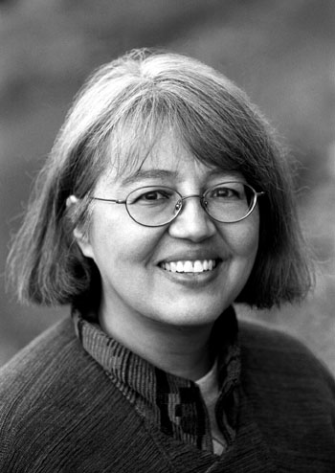Loriene Roy
Celebrating Community, Collaboration, and Culture

Highlights: Social Responsibilities
Professor, School of Information, The University of Texas at Austin.
Professor, Center for Women’s and Gender Studies, The University of Texas at Austin.
Director, “If I Can Read, I Can Do Anything,” A Reading Promotion Project for Schools
on Reservations.
Principal Investigator: “Honoring Generations: Developing the Next Generation of Tribal
Librarians,” Recruiting and Training Librarians for the 21st Century Grant ($341,294), U.S. Institute of Museum and Library Services.
Research Associate, Four Directions, Pueblo of Laguna (New Mexico), Department of
Education, 1997-2001.
Consulting: with tribal college, community/public, and school libraries.
Volunteer Trainer, Austin Free Net, 1997-1998.

Selected Honors:
2005 Mover and Shaker, Library Journal.
Certificate of Appreciation for Outstanding Volunteer Services to Humanities & Government Magnet for International Studies, Fulmore Middle School of Austin Independent School District, 2003.
Outstanding Alumna 2002, School of Information Resources and Library Science, University of Arizona.
Certificate of Appreciation for Making a Significant Contribution to Advancing the Awareness of Women’s History, Austin Public Library, 2002.
Joe and Bettie Branson Ward Excellence Award for Research, Teaching, or Demonstration Activities that Contribute to Changes of Positive Value to Society, The University of Texas at Austin, 2001.

Selected Presentation Venues:
ALA, American Theological Library Association, Goteberg International Book Fair, IFLA, International Indigenous Librarians Forum, Library & Information Association of New Zealand Aotearoa, PLA, Sequoyah Research Center Symposium, Transborder Library Forum, World Indigenous Peoples Conference On Education.

Current Advisory Boards:
El dia de los ninos/El dia de los libros, Advisory Committee, 2004-2005, 2005-2006.
Heart of the Community: The Libraries We Love, Berkshire Publishing Group, 2005-.
International Children’s Digital Library. Advisory Board, 2002-.
WebJunction.org. OCLC. Bill & Melinda Gates Foundation. Public Access Computing Portal, Advisory Committee, 2002-.
Sequoyah Research Center. Advisory Board, 2001-.
Texas State Library and Archives, TexShare Advisory Board, 2005-.

Selected Service:
American Indian Library Association, President, 1997-1998.
ALA, Council Committee on the Status of Women in Librarianship, Member, 1997-1999.
Carla Hayden’s Presidential Advisory Committee.
Carol Brey-Casiano’s Presidential Advisory Committee, Diversity Subcommittee.
Council Committee on the Status of Women in Librarianship
Joint Conference of Librarians of Color, Steering Committee, Evaluation Committee.
Presidential Task Force on Equity of Access: Towards Full Digital Inclusion.
Sarah Long’s Literacy Initiative, Chair, 1998-2000.
Spectrum Initiative Jury, Leadership Institute Committee, Steering Committee.

Selected Publications:
(with Mark Christal and Antony Cherian) “Stories Told: Tribal Communities and the
Development of Virtual Museums,” Journal of Internet Cataloging: The
International Quarterly of Digital Organization, Classification and Access 7 (1) (2005): 65-88.
“Creating Opportunities and Opening Doors: Mentoring Students of Color,” in Wheeler,
Maurice, ed., Unfinished Business: Race, Equity, and Diversity in Library and Information Science Education (Metuchen, NJ; London: Scarecrow, 2005), 131-146.
(with Becky Kyle) “Building a Native Bridge to WebJunction.org,” WebJunction.org, 18
Mary 2004.
(with Dr. David Raitt) “The Impact of IT on Indigenous Peoples,” The Electronic
Library 21 (5) (2003). (co-edited special journal issue)
(with A. Arro Smith) “Supporting, Documenting, and Preserving Tribal Cultural
Lifeways: Library Services for Tribal Communities in the United States,” World
Libraries 12 (1) (Spring 2002): 55-65.
with Aimee Akerman) “OKSALE: Building a Culturally Responsive Virtual Library of Education Resources for a Tribal College,” Education Libraries 25 (2) (Winter 2002): 26-28.
“Diversity in the Classroom: Incorporating Service-Learning Experiences in the Library and Information Science Curriculum,” Journal of Library Administration 33 3/4 (2001): 213-228.
“The International Indigenous Librarians’ Forum: A Professional Life-Affirming Event,” World Libraries 10 (1/2) (Spring/Fall 2000): 19-30.

