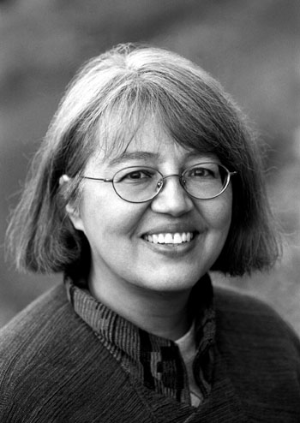
Loriene Roy
Celebrating Community, Collaboration, and Culture

Highlights: Service to Youth

Professor, School of Information, The University of Texas at Austin. Courses taught
include “Public Libraries”
Director, “If I Can Read, I Can Do Anything,” A Reading Promotion Project for Schools
on Reservations. (http://www.ischool.utexas.edu/~ifican)

Selected Publications:

(with Deborah Smith) “A Gathering of Readers: Schools Serving Indigenous Children Collaborate on a Virtual Celebration of Reading and Culture,” 2005 School Library Association of New Zealand Aotearoa (SLANZA) Conference Proceedings, Auckland, Aotearoa/New Zealand, July 2005. [CD ROM]
“American Indian Literacy and Reading,” School Library Media Activities Monthly 20
(6) (February 2004): 23-25
“`If I Can Read, I Can Do Anything,’: Promoting Reading on the Rez,” Texas Alcalde 89 (5) (May/June 2001): 16.
(with Antony Cherian, Mark Christal, Marty Kreipe de Montano, and Paul Resta) “Virtual Museum Collaborations for Cultural Revitalization: The Four Directions Model,” Museums and the Web 2001 Proceedings, Seattle, WA, March 2001. [CD ROM]
“A Conversation with Luci Tapahonso,” The New Advocate 14 (2 (Spring 2001): 111-
117.
“Planning an Oral History Project,” Journal of Youth Services in Libraries 6 (4) (Summer 1993): 409-413.
“National Findings, National Measures: The NCES Survey on Children's Services in Public Libraries and Output Measures for Public Library Service to Children,” Journal of Youth Services in Libraries 6 (2) (Winter 1993): 181-184.
“The Oral History Project of TLA,” Texas Library Journal 68 (2) Summer 1992: 59-62.
“Collection Evaluation as Research,” Journal of Youth Services in Libraries 5 (3) (1992): 297-300.
“What is Qualitative Research?” Journal of Youth Services in Libraries 5 (1) (1991):
105-107.
A Survey of Children's Librarians in Illinois Public Libraries,” Library and Information Science Research 9 (3) (July-September 1987): 182-211.

Book reviews in American Indian Libraries Newsletter, Multicultural Review, and School Library Journal

Selected Fellowships, Grants, Special Honors:

2005 Mover and Shaker, Library Journal.
Certificate of Appreciation for Outstanding Volunteer Services to Humanities/Government Magnet for International Studies, Fulmore Middle School of Austin Independent School District, May 13, 2003.
Joe and Bettie Branson Ward Excellence Award for Research, Teaching, or Demonstration Activities that Contribute to Changes of Positive Value to Society, The University of Texas at Austin, 2001.
Special Recognition of Outstanding Contribution, Four Directions Innovation Technology Grant, Pueblo of Laguna/Laguna Department of Education, 1997.

Selected Presentation Venues Include:

Goteborg International Book Fair, International Association of School Librarianship,
National American Indian and Alaska Native Child Care Conference, School
LibraryAssociation of New Zealand/Aotearoa, Viburnum/Library of Congress Center for
the Book Workshop on Planning and Implementing Family Literacy Projects, World
Indigenous Peoples Conference on Education

Selected Service:

El dia de los ninos/El dia de los libros, Advisory Committee, 2004-2005, 2005-2006.
International Children’s Digital Library. Advisory Board, 2002-.
Association for Library Service to Children, American Library Association
Caldecott Committee, Nominated, 1995.
Oral Record Task Force, Member, 1992-1993.
Oral Record Project Advisory Committee, Member, 1993-1994.
Research and Development Committee, Member, 1989-1993.

