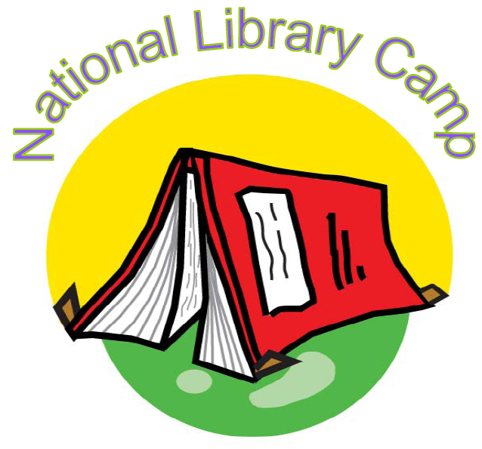
ALA Emerging Leaders 2007
Project Q
Team Members:
Mario Ascencio,
George Mason University
Christy Donaldson,
Utah Valley State College
Jolie Graybill,
Northern Arizona University
Florante Ibanez,
Loyola Law Library

Our Mentors:
Loriene Roy, ALA President-Elect
Kerry Ward, ALA contact

- With baby boomers retiring at increasing rates, a pressing need exists to fill ranks of America’s Librarians and other Information Professionals such as Archivists, Museum Curators, etc. The concept of a National Library Camp is a welcomed project whose time has finally come.
- A National Library Camp -- geared towards middle school and/or high school youth, a place for young people to discover the many aspects and possibilities of library careers -- has the potential to nurture and mentor the next generation of Information Professionals!

- In lieu of re-inventing the wheel, Project Q gathered information – camp statistics and what’s currently happening in existing summer camp programs.
  - More than 12,000 day and resident camps exist in the U.S.
  - Each year, more than 11 million children and adults attend camp.
  - Nonprofit groups operate approximately 8,000 camps – 4,000 are privately owned.
  - Camp Costs: Vary, with average weekly resident fee ranges from $325-$780.
  - In an ACA survey, 75% of camp directors reported adding new activities and programs over the last few years.
  - 65% of camps reported enrollment that stayed the same or increased within the last five years and 35% of camps reported 90-99% full.

What’s Currently Happenin’…

- Upward Bound – Approximately 850 federally mandated programs throughout the US, urban and rural. Summer program component exists allowing ALA opportunity to create a library and information component complimenting the already existing program.

- Trio Program – Unlike Upward Bound, Trio Programs are tied to a specific school. Students accepted into these programs and maintain a certain minimum GPA, are guaranteed acceptance into the University.

- Council for Opportunity and Education – Nonprofit organization established in 1981, dedicated to the expansion of educational opportunities throughout the United States. Through numerous membership services, the Council works in conjunction with colleges, universities, and agencies that host TRIO programs to specifically help low-income Americans enter college and graduate.

What’s Currently Happenin’… continued

- Public Library System Programs:
  - Numerous examples of summer reading programs exist nationwide including Library Camp days and sleep-overs.
  - By utilizing existing programs, incorporating program content such as information career talks, researching assignments, and librarian shadowing would be feasible.
  - Highlights could include visit to the Annual ALA Conference Exhibit Hall, and author talks/luncheon.
  - Outreach and recruitment shared responsibility with local public libraries in host region.

- 2008 ALA Annual Conference in Anaheim, CA:
  - Library graduate schools at UCLA (West Los Angeles) and Cal State Fullerton University (Orange County).
  - Early Outreach Program at the University of California-Irvine.
  - Collaborate with above to implement pilot for 2008.

Considerations…

- ALA should consider partnering with already established programs to incorporate:
  - Research Skills
  - Information Literacy/Fluency Skills
  - Technology Skills

- Skills above are currently absent from many of these programs – and program directors are aware of this gap.

- Hybrid or Virtual Library Camp:
  - Increase participation through virtual participation nationwide
  - Significantly Reduces Cost of participants
  - Utilize iPods, etc. -- downloadable information, participation, and interaction
  - Second Life Teen Grid: Involvement of the SL Teen Grid EYE 4 YOU Alliance (Teen Library Project)

Appendix

- References
  - Bialeschki, M. D. (2006). What's happening with camp enrollment? Camping Magazine, March.
  - http://www.acacamps.org/research/

- Timeline
  - ALA Board presentation – October 2007
  - Grant exploration, 2007
  - Pilot Camp June 2008

