
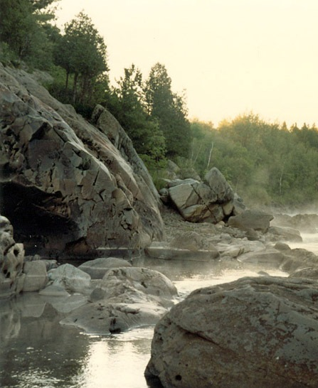
Wellness
Passport
2008

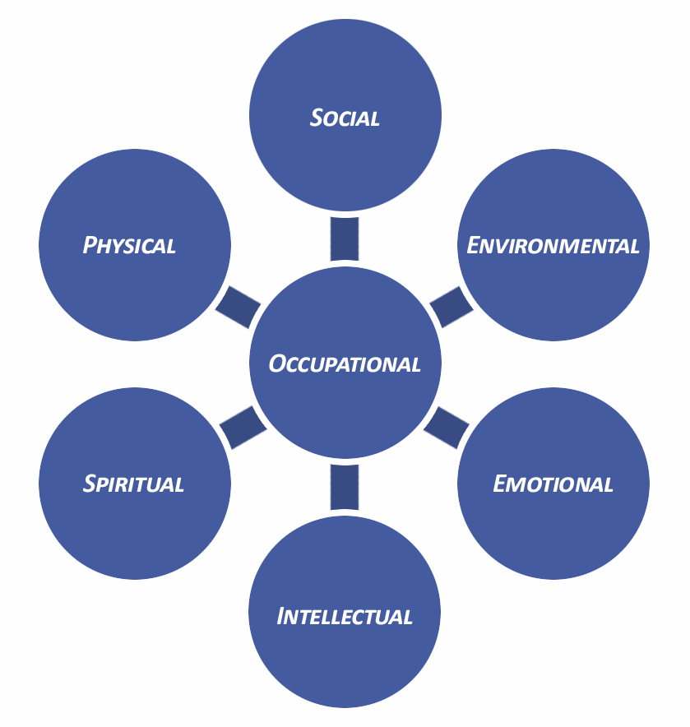

well•ness : the quality or state of being in good health, especially as an actively sought goal

As library employees there are many factors that can affect our overall wellness from day to day. Our own physical health, the strain of outside social influences, dusty stacks and noisy patrons, stressful interactions, either a lack or overload of mental stimuli, and the potential ambiguity of our motivations and personal direction can all contribute to the satisfaction and wellness that we experience in our daily work.

This booklet is designed to help you monitor your personal wellness week by week through daily checks that can lead to overall balance. This is only a guide and additional resources are available at: http://www.ischool.utexas.edu/~loriene/wellness/.

Weekly Health Passport

Complete wellness considers all aspects of a person’s life: physical, social, environmental, emotional, intellectual, spiritual, and occupational, which is the focus of this passport. Each element factors into your daily experiences at work in the library. The checkpoints suggested on the following pages focus on positive changes and observations that you can make to improve and enrich your daily routine in the library.

Before you begin, take time to set some weekly goals:

□ Nutrition Goals: _________________________________
____________________________________________
____________________________________________
____________________________________________
____________________________________________

□ Fitness Goals: ___________________________________
____________________________________________
____________________________________________
____________________________________________
____________________________________________

□ Personal/Time Management Goals: ___________________
____________________________________________
____________________________________________
____________________________________________
____________________________________________

Current hobbies, interests, and pursuits (for relaxation and intellectual stimulation): _____________________________
____________________________________________
____________________________________________

Day 1 Date _________
Physical
□ Nutrition Goals □ Fitness Goals
Social
□ Today I initiated a positive, helpful interaction with
___________________________ .
Environmental
□ Today I ______________________ to improve my work
environment.
Emotional
List two good things that happened to you at work today:
- __________________________________________
- __________________________________________
Intellectual □ Time Management Goals
□ Today I challenged my mind by __________________
__________________________________________ .
Spiritual □ Daily Quiet Time
□ Today I worked toward my personal goals by
__________________________________________ .
Occupational
Take a moment to consider the good things that happened to you at work today and how you might continue to facilitate those experiences.

Day 2 Date _________
Physical
□ Nutrition Goals □ Fitness Goals
Social
□ Today I initiated a positive, helpful interaction with
___________________________ .
Environmental
□ Today I spent positive time outdoors.

Emotional
List two good things that happened to you at work today:
- __________________________________________
- __________________________________________
Intellectual □ Time Management Goals
□ Today I challenged my mind by __________________
__________________________________________ .
Spiritual □ Daily Quiet Time
□ Today was meaningful because
__________________________________________ .
Occupational
□ Today I performed well at work.

Day 3 Date _________
Physical
□ Nutrition Goals □ Fitness Goals
Social
□ Today I initiated a positive, helpful interaction with
___________________________ .
Environmental
□ Today I ______________________ to improve my work
environment.
Emotional
List two good things that happened to you at work today:
- __________________________________________
- __________________________________________
Intellectual □ Time Management Goals
□ Today I challenged my mind by __________________
__________________________________________ .
Spiritual □ Daily Quiet Time
Occupational
The thing that I love most about my job is ______________ .

Day 4 Date _________
Physical
□ Nutrition Goals □ Fitness Goals
Social
□ Today I initiated a positive, helpful interaction with
___________________________ .
Environmental
□ Today I ______________________ to improve my work
environment.
Emotional
List two good things that happened to you at work today:
- __________________________________________
- __________________________________________
Intellectual □ Time Management Goals
□ Today I challenged my mind by __________________
__________________________________________ .
Spiritual □ Daily Quiet Time
List one truth that impacted your day or occurred to you this week: __________________________________________ .
Occupational
Two things that I wish had gone better today:
- ___________________________________________
- ___________________________________________

Day 5 Date _________
Physical
□ Nutrition Goals □ Fitness Goals
Social
□ Today I initiated a positive, helpful interaction with
___________________________ .
Environmental
□ Today I spent positive time outdoors.

Emotional
List two good things that happened to you at work today:
- __________________________________________
- __________________________________________
Intellectual □ Time Management Goals
□ Today I challenged my mind by __________________
__________________________________________ .
Spiritual □ Daily Quiet Time
□ Today I worked toward my personal goals by
__________________________________________ .
Occupational
□ Today I performed well at work.

Weekend

Two things that I will do for myself this weekend:
- _________________________________________
- _________________________________________

Two things that I would like to improve on next week:
- _________________________________________
- _________________________________________

Highlight of the week: ____________________________

Book that I am reading: ___________________________

Good-will Project (what I am doing for others): ________
_________________________________________ .

My overall wellness this week (personal rating):
1 2 3 4 5 6 7 8 9 10

This pamphlet was created for
ALA President
Loriene Roy’s
Circle of Wellness Initiative
By
Ted Chaffin
Sara Jeffress
Jennifer Turner
&
Laura Warren-Gross,
ALA Emerging Leaders, 2008.

